CIS2235 Java Programming I Program 8 200pts Due: Thursday, December 7, 2017
Inheritance, Polymorphism, Interfaces, Packages, and Enigma classes

Turn in requirements:
- 5 pts Please name your Netbeans Project folder LastnameP8, such as NelsonP8.
- 10 pts Upload your zipped project through Blackboard.

Program Requirements:
- 5 pts Write your name, email address, Program name and file name at the top of your source code in a comment
- 5 pts Use write your name, program title, and program objective as the title of the Frame.
- 5 pts Use good Java programming style and formatting for your program. Use appropriate comments to explain what you are doing.

We are going to write a class that encodes and decodes strings of text. We will model our process on the Original Enigma Machine from WWII. The original machine was very complex, but we will encode our secret messages with a two-step encoding process. The process will involve implementing the EnigmaInterface and writing an Enigma super-class. We will then derive three sub-classes from the super class, and use them in the encoding/decoding process. Use Exception Handling for the JTextFields.

Stage 1: The Enigma Super Class:

The algorithm that we’ll use for this class is straightforward. The user passes a string to be encoded into the Enigma object. The Enigma class uses a “key” to encode or decode the message. The key is an integer value between (and including) 1-50. The Enigma class can either generate the key using a random number generator, or is passed in the key. To encode the message string, each character of the message is converted to its associated ASCII numeric value and the key value is added to it. The new number is then converted back to a character. To decode the message, each letter is converted to an int, the key subtracted from it, and the new value converted to a char.

Refer to an ASCII Character Code set appendix in text to see a complete set of decimal/character values.

Example 1: In this example, all ASCII values remain in the 32-126 range after the key has been added.

Message: COMBO IS 7-43-19
Each character C O M B O sp I S sp 7 - 4 3 - 1 9
ASCII values 67 79 77 66 79 32 73 83 32 55 45 52 51 45 49 57
Key = 10, add 77 89 87 76 89 42 83 93 42 65 55 62 61 55 59 67
Encoded message: M Y W L Y * S ] * A 7 > = 7 ; C

Note: The ASCII Character set for the characters on a computer keyboard range from 32 (space) to 126 (~). For our Enigma, you will have to be sure that your coded message characters are all within 32-126. When the key is added to the character, if the value is larger than 126, you will need to figure out a way to have your values “wrap” around in the following manner. The value 127 => 32, 128 => 33, 129 => 34, etc.

Example 2: In this example, some of the new values are above the 126 range after the key has been added to the character. The values must “wrap” to within the valid range (32-126).

Message: See me at 7pm.
Each character S e e sp m e sp a t sp 7 p m .
ASCII values 83 101 101 32 109 101 32 97 116 32 55 112 109 46
Key = 20, add 103 121 121 52 129 121 52 117 136 52 75 132 129 66
Wrapped value 34 41 37 34
Encoded message: g y y 4 “ y 4 u ) 4 K % “ B

Write the Enigma class that performs the encoding and decoding tasks as described above.

The Enigma class has an int for the key, strings for message and coded message, and private encode and decode functions. The Enigma class implements the EnigmaInterface, described below:

The interface code is located in a separate file in the project called EnigmaInterface.java. These are the methods in the interface:
- setMessage, is passed a string that contains the message to be encoded. When this is called, the Enigma class generates its own key using the random number generator.
- setMessage, is passed a string that contains the message to be encoded AND an integer value for the key. This functions checks first that the key is between 1-50. If the input value is not between 1-50, the function sets the key value to 1.
- setCodedMessage, is passed the message to be decoded, as well as the integer key value that was used to code the original message
- getCodedMessage, returns the coded message
- getDecodedMessage, returns the decoded message
- getKey, returns the current key value.

In your application, there should be an Enigma object in the Frame class, along with any needed event handlers including handlers for the Menu Bar. You will also have a Main class, which will initiate the program.

The Enigma Form
Your Form should contain a text field where the user can enter the message to be encoded. There are radio buttons so that the user can pick fixed key or generate key, as well as a means to select the key. Use a Text Field to enter the key. When you drop a Radio Button on the Form, add a ButtonGroup to the form, then check the Properties section for each of the RadioButtons in that group and select the ButtonGroup. Be sure you set one of the Radio Buttons to selected as a default.

In addition, there will be a second group of RadioButtons, containing the names of the three Sub-classes of Enigma. Be sure to add another ButtonGroup for these buttons, and set one as a default.

There will also be a Menu Bar with selections at the top of the Form. The selections are File and About. You will put three menuItems under File. You will add Open File, Save File. Make sure you make action events for the menuItems that we will use. About describes the Enigma program.

Program 7, Enigma is the superclass for inheritance for Program 8. You need to have the Enigma super class correct or the sub-classes will never work. Here is an example of how your form for the Enigma with Polymorphism might look:
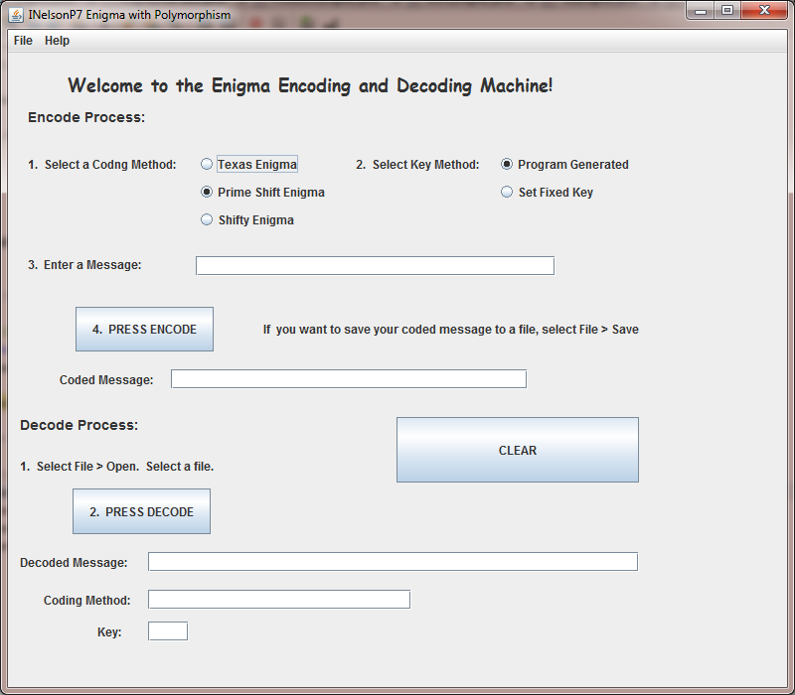

Deriving Enigma sub-classes and adding three RadioButtons
You will add to the program three Enigma subclasses that perform string encoding and decoding. Your messages are written to a user-specified text-based file. The type of encoding and key are written into the file with the coded message. The program will use polymorphism and an array of super class references in order to access the correct sub class.

This will be the work flow for the Encoding part of the Enigma project. For Decoding, the order is reversed.

Secret Message

Enigma super class key-shifts the message

Coded Message

Prime Shift Enigma
Shifty Enigma
Texas Enigma

Coded Message Coded Message Coded Message

The Frame class will have an array of Enigma references, sized to 3 and one of each of the Enigma objects.
Enigma e [] = new Enigma [3];

TexasEnigma te = new TexasEnigma ();
PrimeShiftEnigma pse = new PrimeShiftEnigma();
ShiftyEnigma se = new ShiftyEnigma();

DO NOT create a separate Enigma object! Delete the object from Stage 1.

In the initialize method, you will assign the subclass objects into the array elements.
e[0] = te; //Texas object ref is in 0
e[1] = pse; //PrimeShift object ref is in 1
e[2] = se; //Shifty object ref in 2

In order to have easy access to the 3 different sub classes, we use polymorphism and this super-class reference technique. You will need to have some logic built into your program so that when you know what encoding or decoding scheme is used, you set an integer value for the appropriate one. For example,
The flow of the code will go something like this:

//create a Frame class variable int index and a String for enigmaType
//determine which encoding/decoding scheme is used
//set the index to either 0, 1or 2
//use if/else- if block of code or a switch stmt with your logic to assign appropriate value into the index
//Also set the sub-class description enigmaType at the same time you are setting the index.

//then call the appropriate methods, depending on which event handler you are in and which radio button the user has selected:
e[index].setMessage( message);
e[index].setMessage( message, key);
e.[index].setCodedMessage(message, key );

You will also call the get methods this way, using e[index].

You WILL NOT have three blocks of code calling three different sub class objects. Your program must have the logic to assign the appropriate value into the index, and that index that is used to access the array element.

All three of your encoding/decoding classes use our Enigma class as its superclass. All three will use the Enigma’s key-shift encoder as a first step in the two-step encoding on all messages.

Texas encoding scheme: In this encoding scheme, make two more passes to add shifts with different values on each of the letters in the message (after it has been Enigma key-shifted). The first pass starts at the beginning of the codedMessage and goes to the end. At position 0, the shift is +1, at position 1, the shift is -2. The shift value alternates positive and negative values and the numbers added increase by 1 for each position in the string. If the resulting value > 126, wrap around to 32. If the value is less than 32, wrap around to 126.

The second pass adds numbers running from 1 to the end starting from the end of the codedMessage. Continue to wrap using the same rules. Like this:

CodedMessage = \ y ! ! $ 4 k $ ‘ ! x
Ascii values= 92 121 33 33 36 52 107 36 39 33 120
1st pass: Add: +1 -2 +3 -4 +5 -6 +7 -8 +9 -10 +11
ToGet: 93 119 36 29 41 46 114 28 48 23 131
Wrap: 124 123 118 36
2nd pass: Add 11 10 9 8 7 6 5 4 3 2 1
ToGet: 104 129 45 132 48 52 119 127 51 120 37
Wrap: 34 37 32
CodedMessage: h “ - % 0 4 W ( ) 3 x %

The Decode method will reverse the process.
NOTE: If the message is quite long (how long?) , the numbers may be quite large, so you may have to repeatedly wrap until the value is in the correct range. Assume you may have to do this.

Prime Shift encoding scheme: Each character in the message (after it has been key-shifted) is checked to see if it is a prime number. If it is a prime number, then check if the key is a prime. If the key is a prime, shift to the next prime. If the key is even, shift to the second prime up, else shift to the third prime up. If the number is not a prime, do nothing. The number 1 is NOT prime, but 2 is.

You must be sure that the shift wraps the values and keeps the character range between 32-126. If the next (or previous) prime is out of range, wrap it to the next relevant prime. The numeric values are then converted to a char and that string is the encoded message.

For example, if the character’s value is 37, it is replaced with 41. If the character is 113, the next prime is 127, but that is out of range. So it is wrapped back to 37 (the first prime in our range).

Shifty encoding scheme: Each character in the message (after it has been key-shifted) is converted to its ASCII value. The value is subtracted from 1000, resulting in a triplet of numbers. Each digit of the triplet is then converted to the symbolic value on the keyboard above the numbers 1 – 0. The string of symbols is the encoded message.

For example, if the character’s value is 37, it is subtracted from 1000, resulting in a triplet of 963. The corresponding keyboard characters are (^#.

File specification: The encoded message, key, and coding scheme is written into the text-based file in the following format. You will need to add one more line to write in the SaveFile menu item event handler and one more line to read in the OpenFile menu item event handler. This extra line contains the index of the coding scheme.

First line: encoded message use these values: Texas = 0
Second line: enigma key value PrimeShift = 1
Third line: a number that represents the type of encoding Shifty = 2

Once your program is working well, you’re going to create a Class Library of your Enigma classes, place them in a JAR, and import them into your P8 project.
- Physically remove all four of the Enigma classes (*.java and *.class files and .jar) from your P8folder. Save them somewhere safe, like the desktop. Change the package name in all of the classes to yourlastname.p8.engima; See 2. below.
- Open a Java Class Library project. Use the following package name: yourlastname.p8.engima , such as nelson.p8.enigma; Add all of the Enigma classes to the folder called src in your project.
(Be sure your package is named in all lowercase letters!)
- Compile and deploy a JAR file of the Enigma classes using clean and build. It will be created in the dist folder.
- To use the JAR in your P8 project, you will need to:
  - Move a copy of the enigma JAR into your P8 folder. Somewhere. I put mine in the src folder.
  - Open your P8 NetBeans project (with your program/form) and add the JAR to the Library in your project. Rt-click on Libraries, and you’ll see an Add JAR/Folder Dialog. Check Relative path. Browse to the JAR of your class library, called lastname.p8.enigma.jar, and select it.
  - Import your package of enigma classes to your form.
  - Run your P8 project to make sure everything is ok.
  - Create a JAR of Project P8 using Clean and build.
  - BE SURE that you physically delete any Engima.java and .class files in your P8 project!!! This ensures that your code is using your Enigma package in the JAR.

P5B Grading Rubric:

Time Due: 5:30 PM You will not have time to finish your program in the lab this day.
Grade breakdown: 200 points total
20 pt You participate in running test cases in lab on other students’ files
Your program must be running in order for this portion of the score.
20 pts Your P8 successfully imports and uses your Enigma JAR
You must be sure that there are no Enigma.java/.class files in your P8 project.
20 pts Your P8 JAR works and I can run your program without being in NetBeans
60 pt (20 pts each) Successful encoding and decoding of each of your 3 techniques
10 pts Enigma super class array and polymorphism used correctly
20 pts Your user interface is simple to use. You follow program specs as described here in this document.
50 pts Other program specs met

Grading Note: At 5:30 PM, if your program is working, you will be given a grading procedure instruction sheet that describes how all of you will encode messages (drop on the Q Assignments drive in folder Q:Assignments > INelson>>AAAJavaMessages) and then obtain the messages from the Q Instructor drive and decode them.

When you hand in your P8 Project, create a file named LastnameP8. Put two zipped files inside that folder.
- Zip and upload your P8 project with all of the files in it, that is, before you removed any files and added the JAR of the Enigma files to the project.
- Upload 8 your completed P8 project with the Enigma library JAR loaded in it. Be sure you have created a Jar of this project with Clean and Build. I should be able to run it as your final project.
Put both of these zipped file into your LastnameP8 folder, zip it and upload it to Blackboard.

